Sycamore Grove Park
Upper Livestock Grazing Management Zone

Spring Forage Production Report - 2025
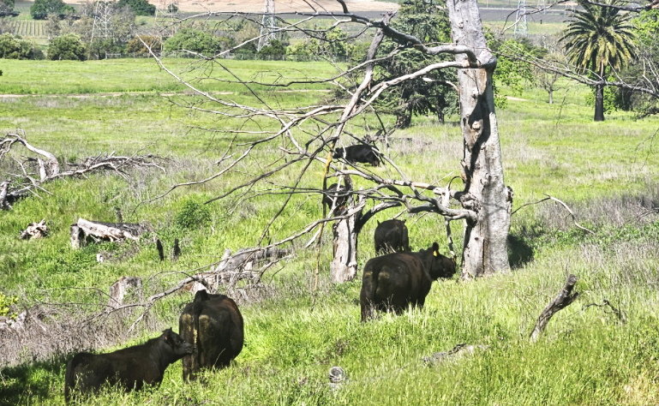

PREPARED FOR:
Livermore Area Park and Recreation District
C/O Marc Roberts
4444 East Avenue
Livermore, CA 94550
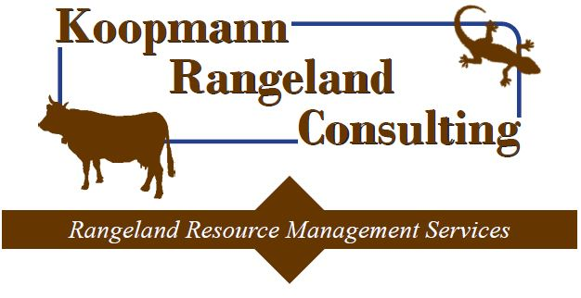
(925) 449-8706

PREPARED BY:
Koopmann Rangeland Consulting
CRM #M-100
April 2025
BACKGROUND:
The Livermore Area Park and Recreation District (LARPD) originally acquired the 364-acre Sycamore Grove Park property in 1975 and later expanded in 1999 and 2015 to include a total of 847-acres. Sycamore Grove Park (Park) is located at 1051 Wetmore Road on the southern edge of the town of Livermore in Alameda County, California. Throughout the years, the primary focus of the Park has been to provide low-intensity public recreation opportunities including hiking, biking, and equestrian use while working to conserve and enhance natural resource values within the Park. Natural resource objectives prioritized by LARPD include reducing the presence of Medusahead, mitigating for wildfire by reducing fine fuels, and enhancing habitat for special status wildlife species including the California tiger salamander (CTS) and California red-legged frog (CRLF).
While the Park property was historically grazed with livestock prior to 1975, livestock grazing has not occurred on the property since the LARPD acquisition. LARPD has conducted controlled burns annually on upper portions of the Park. In an effort to more efficiently achieve the natural resource objectives within the Park, LARPD has opted to commence grazing with beef cattle on the upper portion of the Park, encompassing an area of approximately 400-acres (Figure-1). Grazing within the Park will adhere to recommendations and prescriptions in a Grazing Management Plan prepared by Lisa Bush, California Certified Rangeland Manager, in 2010. LARPD recently installed new fencing and gates to accommodate livestock grazing and entered into a grazing lease agreement with Flynn Road Ranches to graze cattle in the Park beginning in April of 2025.

GRAZING MANAGEMENT GOALS & OBJECTIVES:
In April of 2025 livestock grazing will be reintroduced to the Park to assist in meeting the resource and vegetation management objectives prescribed in the Grazing Management Plan (GMP) (Bush, Lisa. 2010). Grazing Management Goals and Objectives identified in the GMP include:
- Goal 1: Reduce Medusahead area coverage.

  - Objective 1a: Reduce seed output of Medusahead using high-intensity, short-duration grazing in spring as soon as the flag leaf (the last least to emerge before the flower head) thickens.

- Goal 2: Improve conditions for native grasses and wildflowers.

  - Objective 2a: Provide seasonal grazing, allow a non-grazing period each year during which native perennial grasses can develop carbohydrate reserves and recover from grazing impacts.

  - Objective 2b: Provide grazing during the rapid spring growth period to reduce the canopy height of, and competitive ability of, non-native annual grasses.

  - Objective 2c: Provide grazing to prevent thatch buildup and create small openings, exposing soil for germination and growth of small-statured flowers.

- Goal 3: Improve habitat conditions for CTS.

  - Objective 3a: Provide grazing to encourage ground squirrel colonization in non-high use public areas.

- Goal 4: Improve habitat conditions for CRLF.

  - Objective 4a: Allow livestock partial access to all ponds that provide habitat or potential habitat for CRLF, to ensure a mix of emergent vegetation and open water.

- Goal 5: Reduce long-term and short-term fire hazard.

  - Objective 5a: Prevent brush invasion into grasslands by annual grazing.

  - Objective 5b: Reduce wildfire by slowing its spread, shortening flame length, and reducing fire intensity by significantly reducing herbaceous fire fuels through annual grazing.
As part of the grazing management on the property, annual rangeland monitoring is required to ensure that grazing activity is effective and forage levels remain within the prescribed, target Residual Dry Matter (RDM) standards. RDM monitoring also allows the grazing operator an opportunity to assess the efficacy of livestock grazing and to make adaptive management decisions in subsequent grazing seasons to more accurately meet the prescribed forage standards. RDM monitoring and rangeland assessments should be conducted in the fall of each year, prior to the first fall/winter rainfall (ideally in late September or early October). In addition to fall RDM monitoring, a spring phytomass assessment is required to determine annual forage production estimates.
Recommended RDM standards in the grazing management plan, and dually noted within the grazing lease agreement between LARPD and Flynn Road Ranches, require:
“Grazing shall be conducted so as to leave standing no less than an average of 800 pounds per acre of residual dry matter (RDM) on the Property throughout the grazing season, as determined by the Lessor. Excluded from the RDM calculations are pastures that are burned, roads and rock outcroppings. Notwithstanding the average RDM requirement set forth in the paragraph, in no event shall the Lessee permit grazing that leaves at the conclusion of a Grazing Season less than 400 pounds per acre RDM on any portion of the Property. Failure to meet the average of 800 pounds per acre RDM or the minimum of 400 pounds per acre on any portion of the Property shall constitute overgrazing.”

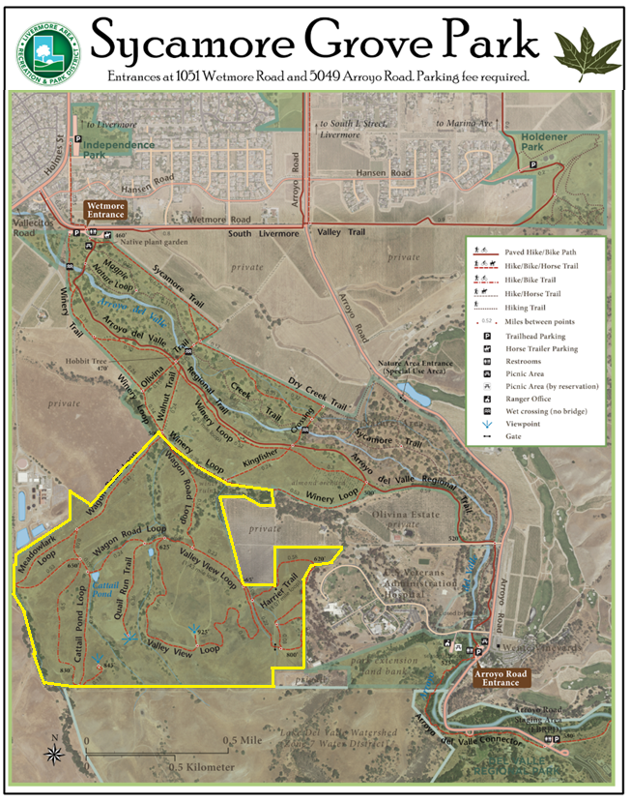
Figure-1: Map of Sycamore Grove Park with planned grazing use outlined in yellow.
FORAGE PRODUCTION ESTIMATE – SPRING 2025:
RDM monitoring generally occurs in the fall of the year (September or October) and measures the weight of dry vegetation on the landscape while phytomass estimates refer to the mass or volume of all living and dead plants on the landscape. The phytomass estimates better specify forage volume/production estimates that occur in the Spring months during the growing season. Both Residual Dry Matter and Phytomass are defined below:

Residual Dry Matter: Residual dry matter refers to the amount of old, dry plant material left standing or on the ground at the start of a new growing season. It's a measure used by land managers to assess the previous season's grazing use and condition of rangelands, especially in California. RDM provides valuable information about forage production, grazing intensity, and overall site health.

Phytomass: Phytomass refers to the total mass of plant material, including both living and dead plant matter, within a given area or ecosystem. It's a measure of the total weight of plants present at a specific time.

The upper portion of Sycamore Grove Park has been absent of grazing for well over 30-years leading to a large accumulation of thatch, a dense layer of dead/decaying vegetation amassed from multiple seasons without grazing or any other type of disturbance. A few areas within the Park have been burned in recent years leading to a reduction in thatch, however, the removal of thatch has led to optimal growing conditions for annual grasses resulting in extremely high forage production. Much of the area proposed for grazing is comprised of forage species that are desirable for livestock consumption including introduced non-native palatable grasses and low forbs. Sporadic patches of native perennial bunch grasses were noted, primarily in the canyon south of Cattail Pond. In addition to desirable forage species, non-native invasive plants that are less desirable as grazing forage inhabit the grasslands including but not limited to black mustard, ripgut brome, Medusahead, Italian thistle, Milk thistle, and bull thistle.

During an April 2025 site visit ocular forage production assessments where performed throughout the proposed grazing unit within the Park to estimate average phytomass. In many locations grassland vegetation averaged nearly 4-feet tall with a dense understory of thatch in addition to filaree and clovers. Based on estimates during the site visit, the average phytomass throughout the pasture is determined to be in excess of 10,000 pounds per acre with many areas in excess of 15,000-20,000 pounds per acre. Phytomass estimates throughout the southern half of the property were substantially higher, on average, than the northern half of the pasture.

RECOMMENDATION:

Per the 2010 Grazing Management Plan, the estimated carrying capacity for Upper Sycamore Grove Park is 691 AUMs which is equivalent to 57 cows grazing year-round. Based on the abundance of forage within the grazing unit, I would recommend stocking the pasture at a higher stocking rate initially to break up the accumulated thatch layer and help achieve the desired level of RDM. Once the thatch has dissipated and annual grasses are reduced, there should be an increase in the presence of desirable vegetation throughout the pasture. Achieving this objective may take 2-3 grazing seasons, at which point, the stocking rate should be reduced to the level as recommended in the Grazing Management Plan.

A small pasture located just south of Cattail Pond has been excluded from the primary grazing pasture to “protect” native perennial bunch grasses. This small pasture should be grazed for a short duration to remove competing annual grasses and then rested to allow native perennial grasses to recover from grazing pressure. The ideal time to graze perennial grasses in California is generally late fall, winter, and/or early spring. If summer grazing occurs, grazing should take place during mid-summer near maximum plant dormancy.

PRE-GRAZING PHOTOS:

Below are a series of photographs captured from the Upper Sycamore Grove Park pasture prior to the commencement of cattle grazing in early April of 2025. These photographs can be used as reference and may also be duplicated at a later date to provide a comparison of pre-grazing versus post-grazing forage conditions within the pasture.

